**Name:**Shradha Mallikarjun Patil

**USN:**2GI20CS144

**TERMWORK-10**

Design and develop a GUI application to accepts student details as shown in the GUI below. Allow the user to add records one after the other. Once the user clicks on close, compute the average score and display the details using JTable component.

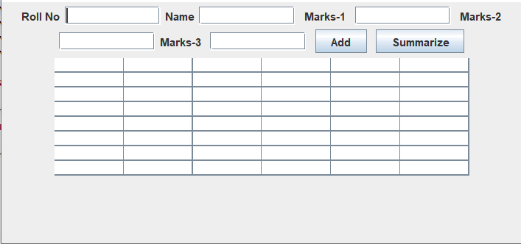

# Program:

package termwork_10_pp1;

import java.util.ArrayList;

import java.awt.EventQueue;

import javax.swing.JFrame;

import java.awt.FlowLayout;

import javax.swing.JLabel;

import javax.swing.JTextField;

import javax.swing.JTable;

import javax.swing.table.DefaultTableModel;

import javax.swing.JButton;

import java.awt.event.ActionListener;

import java.awt.event.ActionEvent;

public class GUI3 extends

javax.swing.JFrame{ class StudentRecord{

String name;

int rollNo, m1, m2, m3;

StudentRecord(int rollNo, String name, int m1, int m2, int m3){ this.name = name;

this.rollNo = rollNo; this.m1 = m1; this.m2 = m2; this.m3 = m3;

}

}

ArrayList<StudentRecord> records = new ArrayList<StudentRecord>(); private JFrame frame;

private JTextField textField; private JTextField textField_1; private JTextField textField_2; private JTextField textField_3; private JTextField textField_4;

private JTable table;

/**

* Launch the application.

*/

public static void main(String[] args) { EventQueue.invokeLater(new Runnable() { public void run() {

try {

GUI3 window = new GUI3(); window.frame.setVisible(true);

} catch (Exception e) { e.printStackTrace();

}

}

});

}

/**

* Create the application.

*/

public GUI3() { initialize();

/**

* Initialize the contents of the frame.

*/

private void initialize() { frame = new JFrame();

frame.setBounds(100, 100, 450, 300); frame.setDefaultCloseOperation(JFrame.EXIT_ON_CLOSE); frame.getContentPane().setLayout(new FlowLayout(FlowLayout.CENTER, 5, 5));

JLabel jbl1 = new JLabel("Roll No"); frame.getContentPane().add(jbl1);

textField = new JTextField(); frame.getContentPane().add(textField); textField.setColumns(10);

JLabel jbl2 = new JLabel("Name"); frame.getContentPane().add(jbl2); textField_1 = new JTextField(); frame.getContentPane().add(textField_1); textField_1.setColumns(10);

JLabel label = new JLabel(""); frame.getContentPane().add(label);

JLabel jbl3 = new JLabel("Marks-1"); frame.getContentPane().add(jbl3); JLabel label_1 = new JLabel(""); frame.getContentPane().add(label_1);

textField_2 = new JTextField(); frame.getContentPane().add(textField_2); textField_2.setColumns(10);

JLabel label_2 = new JLabel(""); frame.getContentPane().add(label_2); JLabel jbl4 = new JLabel("Marks-2"); frame.getContentPane().add(jbl4);

textField_3 = new JTextField(); frame.getContentPane().add(textField_3); textField_3.setColumns(10);

JLabel jbl5 = new JLabel("Marks-3"); frame.getContentPane().add(jbl5); JLabel label_3 = new JLabel(""); frame.getContentPane().add(label_3);

textField_4 = new JTextField(); frame.getContentPane().add(textField_4); textField_4.setColumns(10);

JButton b1 = new JButton("Add");

b1.addActionListener(new ActionListener() { public void actionPerformed(ActionEvent e) {

StudentRecord s1 = new StudentRecord(Integer.parseInt(textField.getText()), textField_1.getText(), Integer.parseInt(textField_2.getText()), Integer.parseInt(textField_3.getText()), Integer.parseInt(textField_4.getText()));

records.add(s1); textField.setText(""); textField_1.setText(""); textField_2.setText(""); textField_3.setText(""); textField_4.setText("");

}

});

JLabel label_4 = new JLabel(""); frame.getContentPane().add(label_4); frame.getContentPane().add(b1);

JButton b2 = new JButton("Summarize"); b2.addActionListener(new ActionListener() { public void actionPerformed(ActionEvent e) { int rowCount = 0;

for(StudentRecord s : records) { table.setValueAt(s.rollNo, rowCount, 0);

table.setValueAt(s.name, rowCount, 1);

table.setValueAt(s.m1, rowCount, 2);

table.setValueAt(s.m2, rowCount, 3);

table.setValueAt(s.m3, rowCount, 4); float avg = (s.m1 + s.m2 + s.m3) / 3.0f;

table.setValueAt(String.format("%.2f", avg), rowCount, 5); rowCount++;

}

}

});

JLabel label_5 = new JLabel(""); frame.getContentPane().add(label_5); frame.getContentPane().add(b2);

table = new JTable(); table.setModel(new DefaultTableModel( new Object[][] {

{null, null, null, null, null, null},

{null, null, null, null, null, null},

{null, null, null, null, null, null},

{null, null, null, null, null, null},

{null, null, null, null, null, null},

{null, null, null, null, null, null},

{null, null, null, null, null, null},

{null, null, null, null, null, null},

},

new String[] {

"Roll No", "Name", "Marks 1", "Marks 2", "Marks 3", "Average"

}

));

frame.getContentPane().add(table)

}

**INPUT AND OUTPUT:**

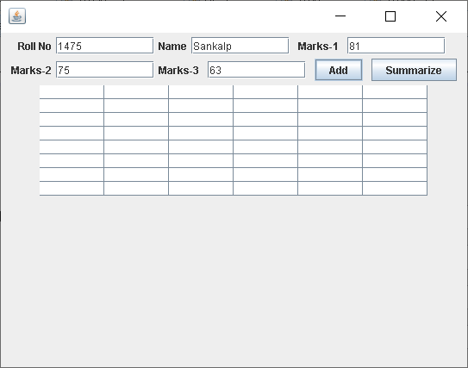

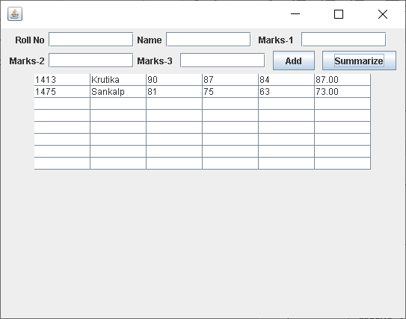

**TERMWORK 10.3**

10.3) Design and implement a Home loan Emi calculator using appropriate Swing

components. The GUI should like as under:

The formula to compute Home loan EMI for a given Principal amount PA and interest

rate IR for a period of T years is

EMI = ( PA + (PA * IR * T))/12*T ;

Hint : Use SlideBars for Amount and Loan Period LoanType - ComboBox

**Code:**

import java.awt.*;

import java.awt.event.*;

import javax.swing.*;

public class emiCalculator extends JFrame {

private JTextField jtfInvestmentAmount;

private JTextField jtfAnnualInterestRate;

private JTextField jtfNumberOfYears;

private JTextField jtfFutureValue;

private JButton jbtCompute;

private JButton jbtReset;

public emiCalculator() {

setTitle("Loan Calculator");

setDefaultCloseOperation(JFrame.EXIT_ON_CLOSE);

setSize(500,300);

setLocationRelativeTo(null);

setLayout(new GridLayout(5,2,5,5));

JLabel jlInvestmentAmount = new JLabel(" Investment Amount");

JLabel jlNumberOfYears = new JLabel(" Number of Years");

JLabel jlAnnualInterestRate = new JLabel(" Annual Interest Rate");

JLabel jlFutureValue = new JLabel(" Future Value");

jtfInvestmentAmount = new JTextField();

jtfNumberOfYears = new JTextField();

jtfAnnualInterestRate = new JTextField();

jtfFutureValue = new JTextField();

jtfFutureValue.setEditable(false);

jbtCompute = new JButton("Compute");

jbtReset = new JButton("Reset");

add (jlInvestmentAmount);

add (jtfInvestmentAmount);

add (jlNumberOfYears);

add (jtfNumberOfYears);

add (jlAnnualInterestRate);

add (jtfAnnualInterestRate);

add (jlFutureValue);

add (jtfFutureValue);

add (jbtCompute);

add (jbtReset);

ListenerClass listener = new ListenerClass();

jbtCompute.addActionListener(listener);

jbtReset.addActionListener(listener);

setVisible(true);

}

public static void main(String[] args) {

new emiCalculator();

}

private void computeValue() {

try {

double annualInterestRate = Double.parseDouble(jtfAnnualInterestRate.getText());

double monthlyInterestRate = annualInterestRate / 1200.0;

int NumberOfYears = Integer.parseInt(jtfNumberOfYears.getText());

double investmentAmount = Double.parseDouble(jtfInvestmentAmount.getText());

double futureValue = investmentAmount * Math.pow(1.0 + monthlyInterestRate, NumberOfYears * 12);

jtfFutureValue.setText(String.format("%.2f", futureValue));

} catch (Exception e) {

JOptionPane.showMessageDialog(null, " Please enter numeric values.");

}

}

private void resetForm() {

jtfInvestmentAmount.setText("");

jtfAnnualInterestRate.setText("");

jtfNumberOfYears.setText("");

jtfFutureValue.setText("");

}

private class ListenerClass implements ActionListener {

public void actionPerformed(ActionEvent e) {

if (e.getSource() == jbtCompute) {

computeValue();

}

if (e.getSource() == jbtReset) {

resetForm();

}

}

}

}

**Output:**

